Recruitment Advertisements

SONA ADVERTISEMENT 1
Prolific Advertisement 1
Mturk Advertisement 2
SONA PAID ADVERTISEMENT 2

SONA ADVERTISEMENT (Individual Recruitment)

STUDY NAME: Understanding emotion regulation
RESEARCHERS: Dr Kit Double
ETHICS APPROVAL NUMBER:
BRIEF ABSTRACT: In this study, you will be asked to complete some surveys about yourself. You will then EITHER view some emotionally negative material or help someone else regulate their emotions while they view emotionally negative material.
DETAILED DESCRIPTION OF STUDY: If you decide to take part in this study, you will be asked to complete surveys about your thoughts, emotions, beliefs, and personality. You will then be matched with another person who is completing the study at the same time as you. You and your partner will be assigned to either view some negative stimuli (e.g. images, videos) while receiving assistance from your partner, OR you will be assigned to provide assistance to your partner who is viewing negative images. You will not be in the same room as your partner and assistance will take the form of short text-based messages that you can send to them.

Prolific Advertisement

*time and pay will vary, but will always be at a rate of 5 pounds per hour

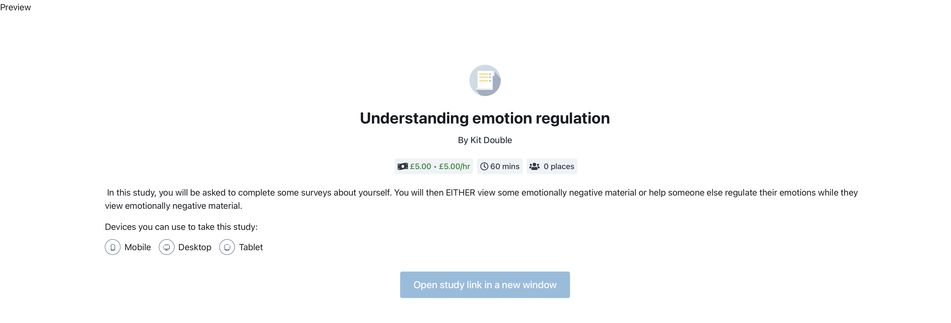
*time and pay will vary, but will always be at a rate of 5 pounds per hour

Mturk Advertisement

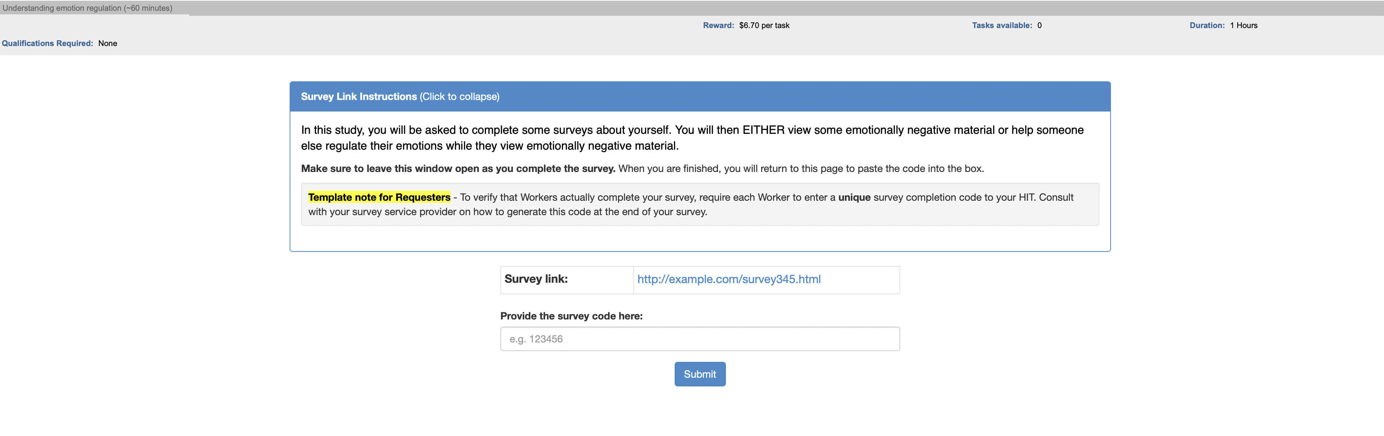
*time and pay will vary, but will always be at a rate of 5 British pounds (approx. $6.70 USD) per hour

SONA PAID ADVERTISEMENT

STUDY NAME: Understanding Emotion Regulation
RESEARCHERS: Dr Kit Double
ETHICS APPROVAL NUMBER:
BRIEF ABSTRACT: In this study, you will be asked to complete some surveys about yourself. You will then EITHER view some emotionally negative material or help someone else regulate their emotions while they view emotionally negative material.
DETAILED DESCRIPTION OF STUDY: If you decide to take part in this study, you will be asked to complete surveys about your thoughts, emotions, beliefs, and personality. You will then be matched with another person who is completing the study at the same time as you. You and your partner will be assigned to either view some negative stimuli (e.g. images, videos) while receiving assistance from your partner, OR you will be assigned to provide assistance to your partner who is viewing negative images. You will not be in the same room as your partner and assistance will take the form of short text-based messages that you can send to them.

You will be compensated for your time at a rate of [$10/hr for online $20 p/h for face-to-face]*.

*time and pay will vary, but will always be at a rate of $10 per hour for online or $20 per hour for face-to-face

